12.37: a) For a circular orbit, Eq. (12.12) predicts a speed of

The speed doesn’t have this value, so the orbit is not circular. b) The escape speed for any object at this radius is 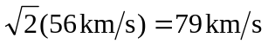, so the spacecraft must be in a closed elliptical orbit.

